Silent Auction Form
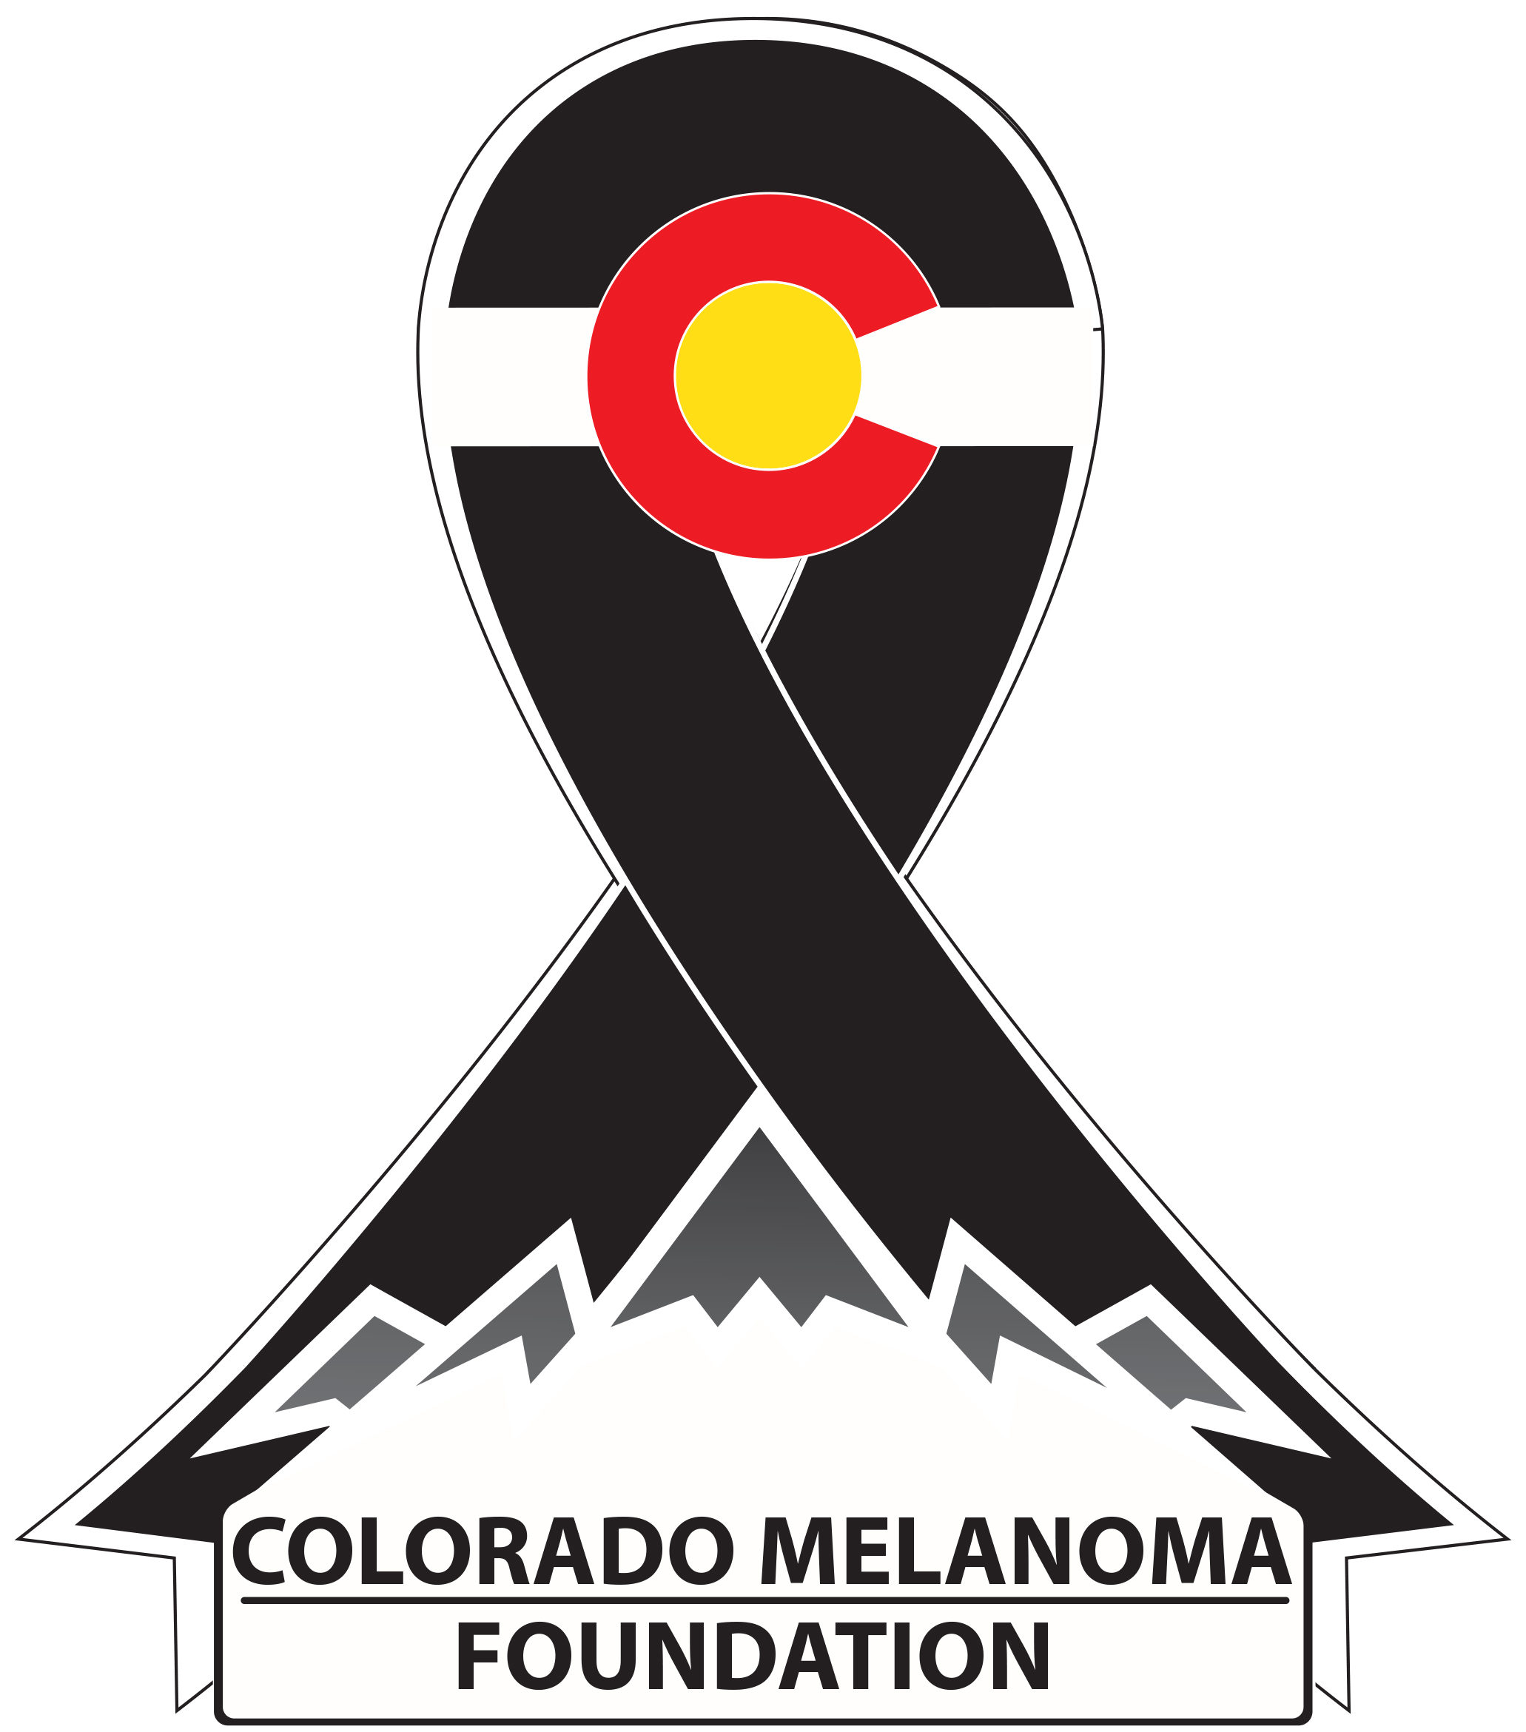 | Colorado Melanoma Foundation  Mallets for Melanoma 2017

Donor Information (please print or type)

Company Name

Location
Item Information Displayed on Website and at Event

Item Name/Title

Estimated Value

Description/Contents

Restrictions

(if applicable)

Acknowledgement Information
Please use the following name(s) in all acknowledgements:

☐I (we) wish to have our gift remain anonymous.

Colorado Melanoma Foundation

3124 S Parker Rd

Aurora, CO 80014

